Capital Goods: Ventura Application Prod Environment Build Requirement Definition Document (RDD)

Hello Boris(CTO),

As concluded today in our call:
- Capital Goods is a diversified company operating across multiple manufacturing domains, including Grocery, Machinery, Electronics, and Clothing. Currently, all customer interactions and sales are conducted exclusively through physical retail locations across these business units.
In recent years, there has been a significant increase in demand for Clothing and Electronics, driven largely by the rapid growth of e-commerce. Market analysis indicates that a substantial portion of purchases in these categories is now conducted online. Internally, we have also observed a consistent rise in customer inquiries and requests for online purchasing capabilities, particularly within these two product lines. Our data shows that approximately 65%–70% of our customers prefer an online shopping experience, highlighting a clear shift in customer expectations and behavior.
Based on these trends, we anticipate a projected 200% growth in our customer base once an online platform is introduced, as it will remove geographical limitations and enable customers to engage with our services from anywhere.
To address this opportunity, Capital Goods is initiating the development and deployment of the Ventura application, a digital platform that will allow customers across the United States, Canada, and South America to browse and purchase products seamlessly at any time. This initiative is aimed at expanding market reach, improving customer experience, and positioning the company competitively in an increasingly digital marketplace.

- The following resource build requirements are strictly for the “Prod” environment only and related questions about this requirement and environment specifications should be targeted to the Senior Solutions Architect Brian Moderate (which is you).

  - 1 RDS instance using MySQL-engine, with high availability configured
  - A Bastion hosts to provide a single point of management of all Instances and DBs
  - 2 load balancers 1 for the web tier and 1 for the application tier
  - 1 instance for the web tier (In an Auto scaling Group)
  - 1 instance for the app tier (In an Auto scaling Group)
  - An S3 bucket to host all app static content, which will be served via CloudFront for a more robust customer experience across geographical locations.
  - Region: us-east-1

Additional details have been provided in confluence. Please find below the confluence URL for your reference

Confluence Pages:

- Compute Environment (Prod)

- Web Servers (Prod)
Number of instance  s | OS | Instance Type | Installations + Configurations | Comments
1 | Ubuntu 24 | t2-medium | Apache (httpd)  Tenable  Shorewall  Crowdstrike  Cloud Watch Agent  AD Join  SELinux Disabled | - Follow our resource naming standards which will be “ventura-prod”-resourcename”  2. Add all our mandatory and strongly recommended labels (  - application id: dmt468  - owner: developers-name  - environment: prod  - budget code: cost-prod  - patch group: pg-prod  - compliance classification: nist  - data classification: pii  - LOB: e-commerce  - project manager: alexander-dirus  - project name: ventura-project  - region: us-east-1

App Servers (Prod)
Number of  instances | OS | Instance Type | Installations + Configurations | Comments
1 | Ubuntu 24 | t2-medium | Apache Tomcat  Tenable  Shorewall  Crowdstrike  Cloud Watch Agent  AD (MS Active Directory) Join  SELinux Disabled | - Following our resource naming standards which will be “ventura-prod”-resourcename”  2. Add all our mandatory and strongly recommended labels (  - application id: dmt468  - owner: developers-name  - environment: prod  - budget code: cost-prod  - patch group: pg-prod  - compliance classification: nist  - data classification: pii  - LOB: e-commerce  - project manager: alexander-dirus  - project name: ventura-project  - region: us-east-1

RDS(MySQL) Instance (Prod)
Number  of instances | Engine | Instance Type (MT) | Multi  AZ (Y/N) | Storage Size (PD) | Template | Comments
1 | MySQL | db.m2.large  (2vCPU, 8Mem) | Y | General Purpose: 100GB | As per environment | 1. Following our resource naming standards  which will be “ventura-prod”-resourcename”  2. Add all our mandatory and strongly recommended labels (  - application id: dmt468  - owner: developers-name  - environment: prod  - budget code: cost-prod  - patch group: pg-prod  - compliance classification: nist  - data classification: pii  - LOB: e-commerce  - project manager: alexander-dirus  - project name: ventura-project  - region: us-east-1

- Amazon Simple Storage Service
  - S3 buckets will be implemented with all mandatory security features enabled (refer to the confluence of S3 security standards).
    - Enable encryption
    - Bucket/Object ACLs
    - Enable Bucket Logging
    - Enable Versioning

2) Network Environment (Prod)
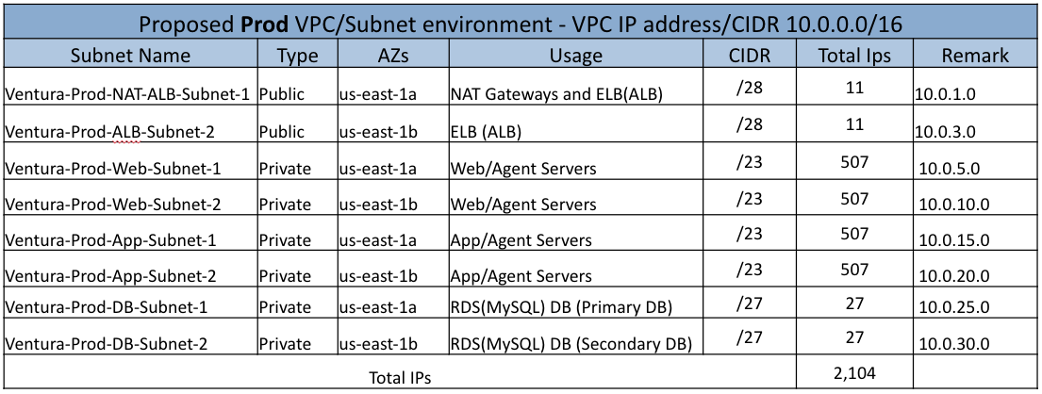

Additional Notes:
- As shown on the architecture, application availability will be achieved by having 2 availability zones at every time.
- On security:
  - In the application, only the web hosts could/may not be publicly facing. But the application and RDS(MySQL) instances must be Private
  - Firewall(Security Group) rules should be configured with the following rules
    - Bastion hosts will allow management connection only from Capital Goods internal network. And all of the other hosts will only allow management connections from the bastion host.
    - The web hosts will allow traffic only from the ELB(ALB) on port 80 and 443 for web requests from source being the ALB Security Group ID. And SSH/22 access through the Bastion Host (IP)
    - Application hosts will only allow application port 80 and 443 traffic connections from the Internal Proxy/Load Balancer Static Internal IP or you could make use of Security Group referential. (Check with the developers if in doubt) and SSH/22 access through the Bastion Host (IP)
    - The RDS(MySQL) instance will only allow database connections from port 3306 from the application hosts
  - In addition, monitoring and logging; alerts and notifications for critical events should be configured. Please refer to our security standard document for more details.

